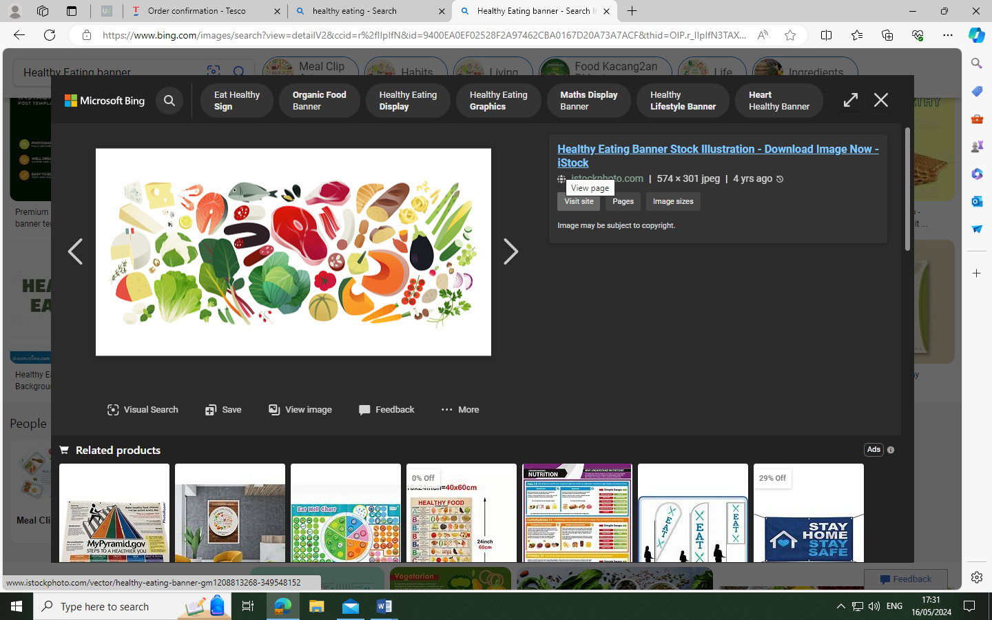
Residential Summer Menu

Week 1. 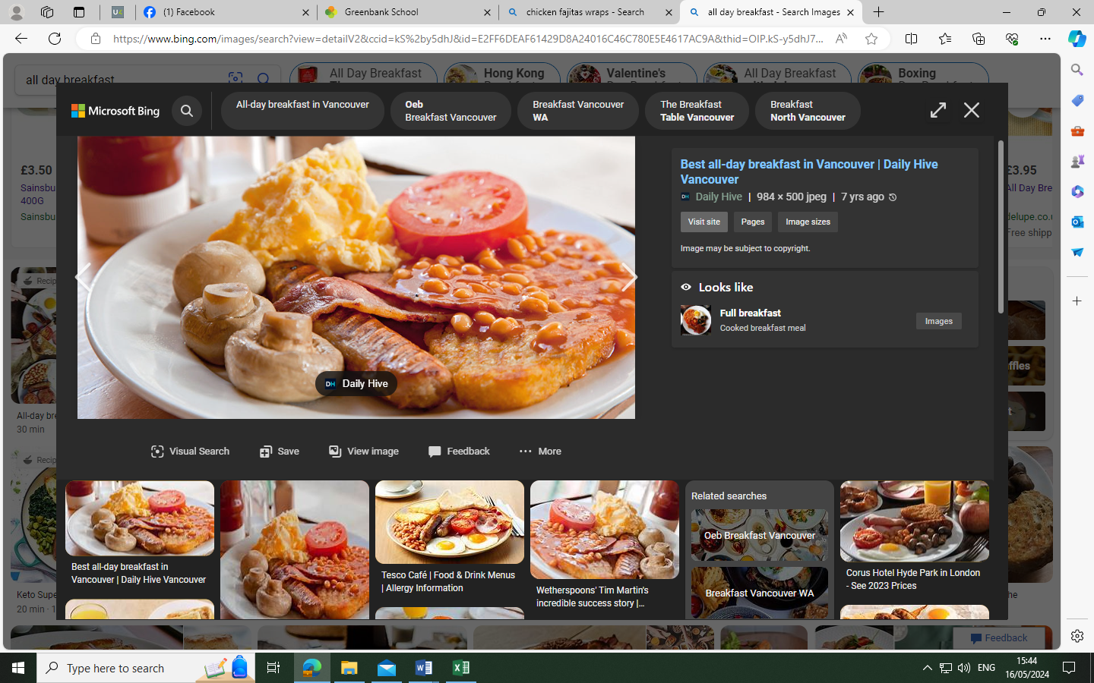 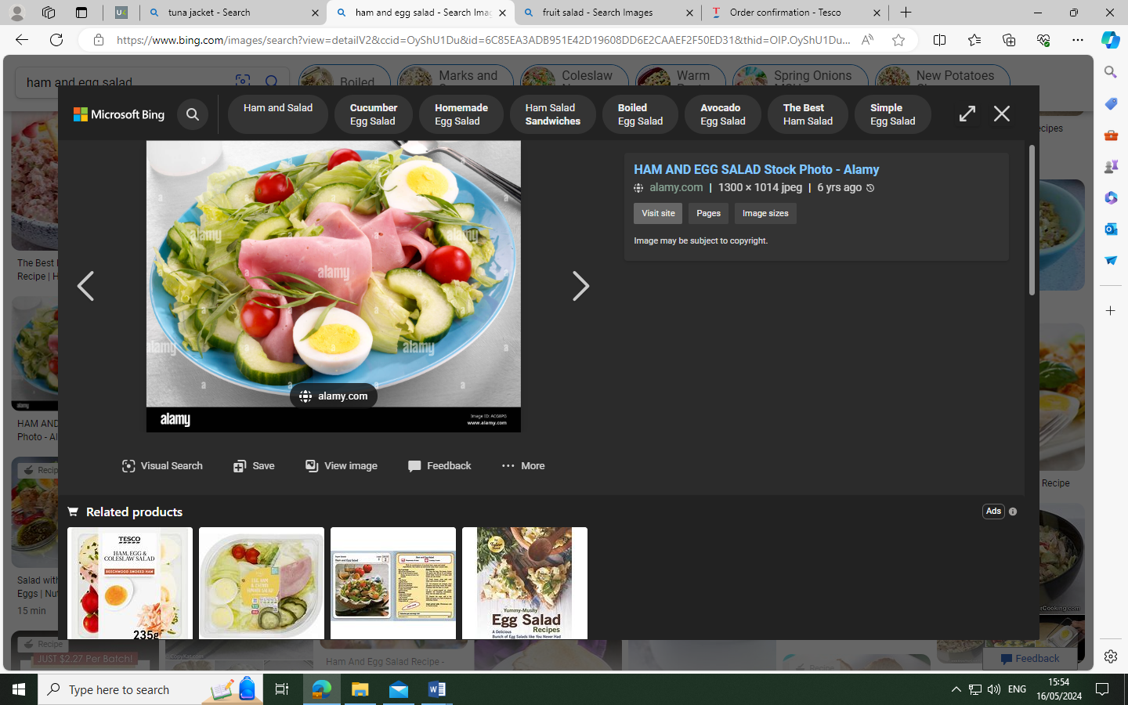 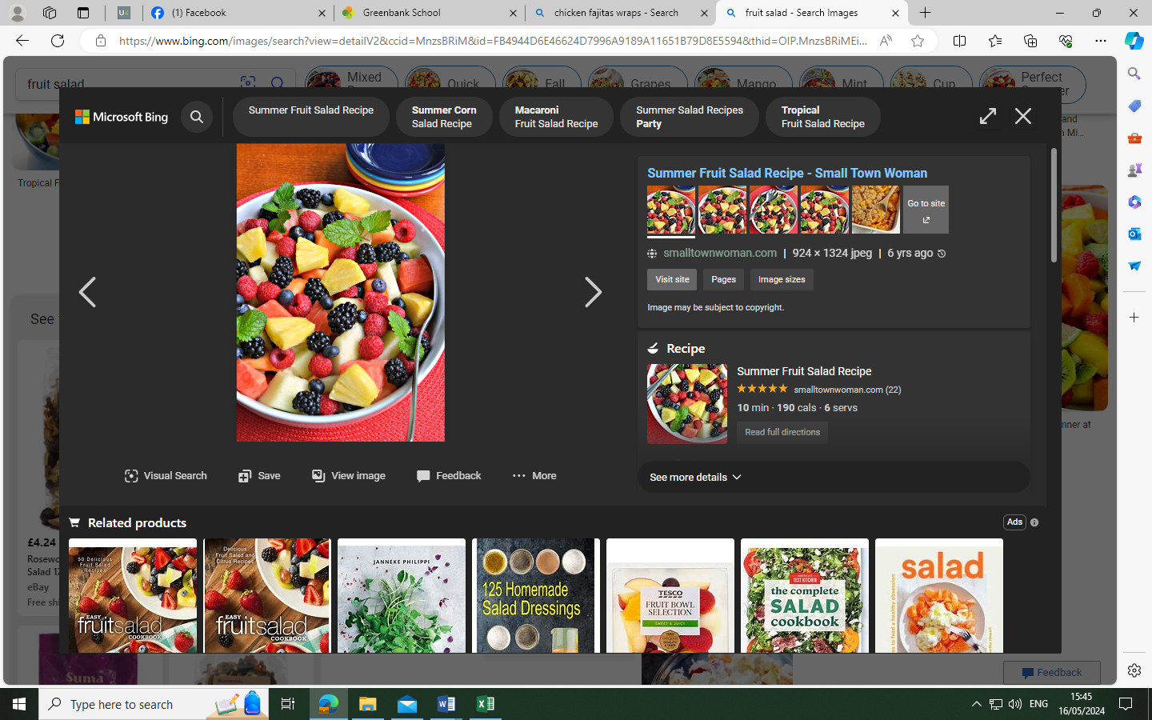
Brunch OR Ham and Egg Salad
Fruit Salad

Week 2. 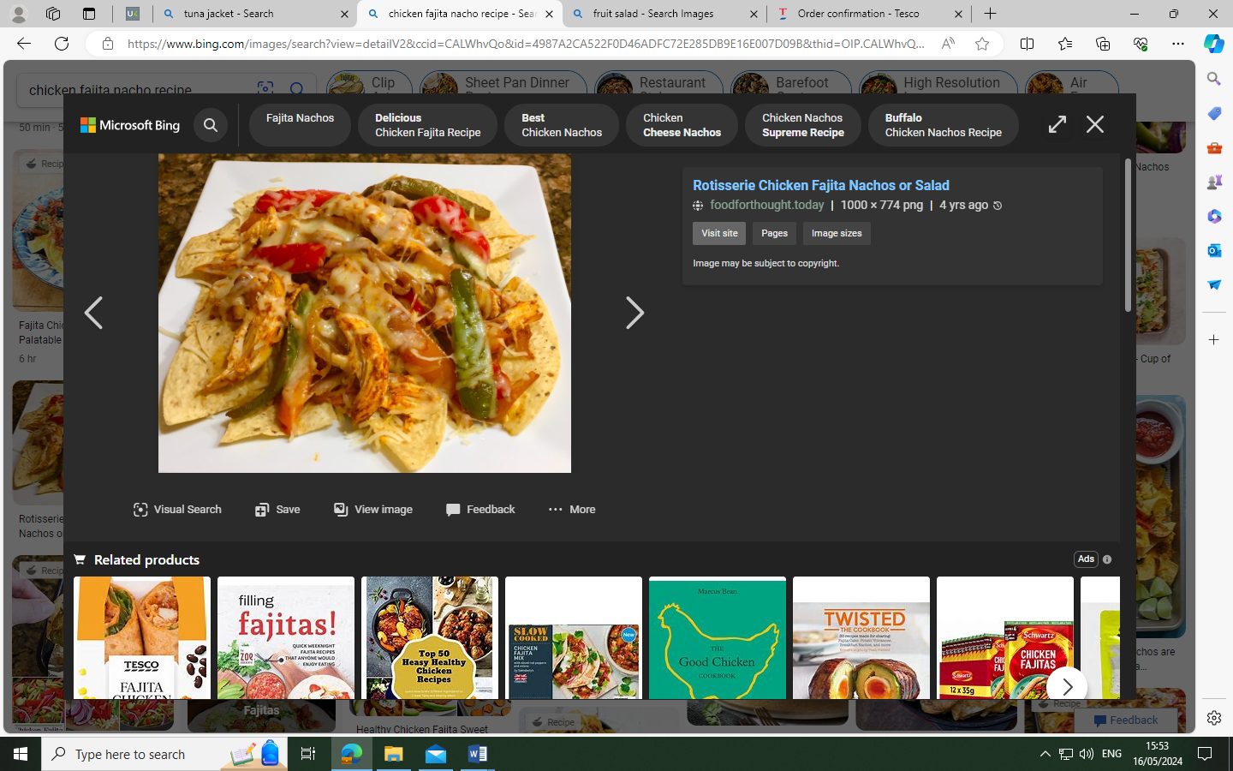 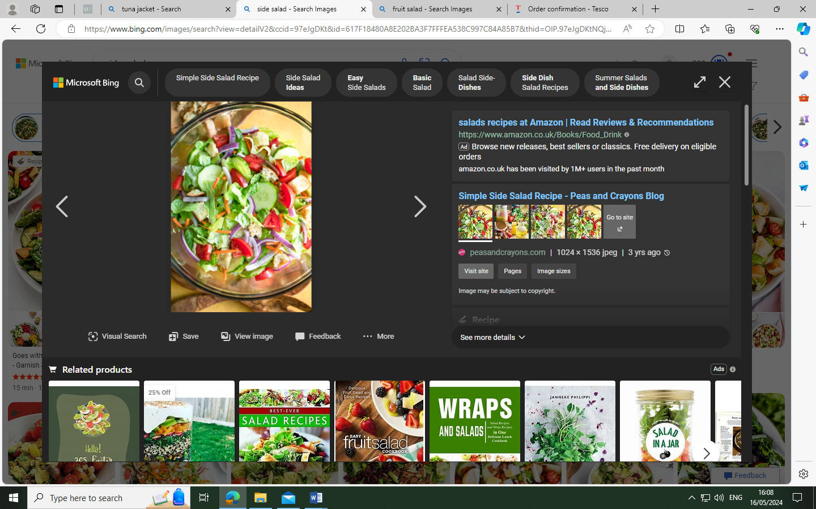 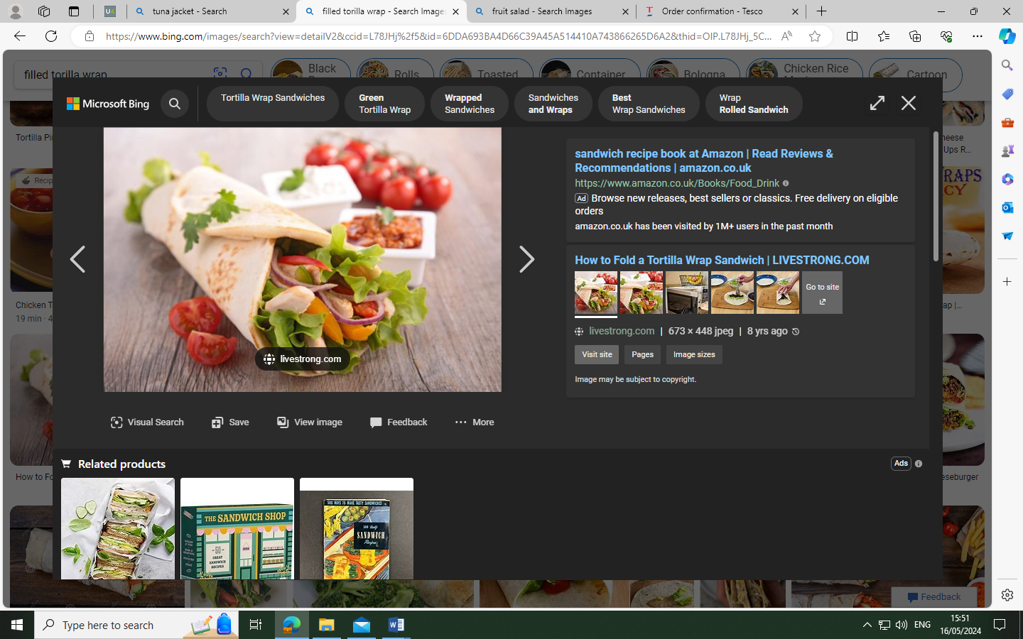
Chicken Fajita with Nachos and Salad OR Filled Wrap and Salad.
Cookie

Week 3. 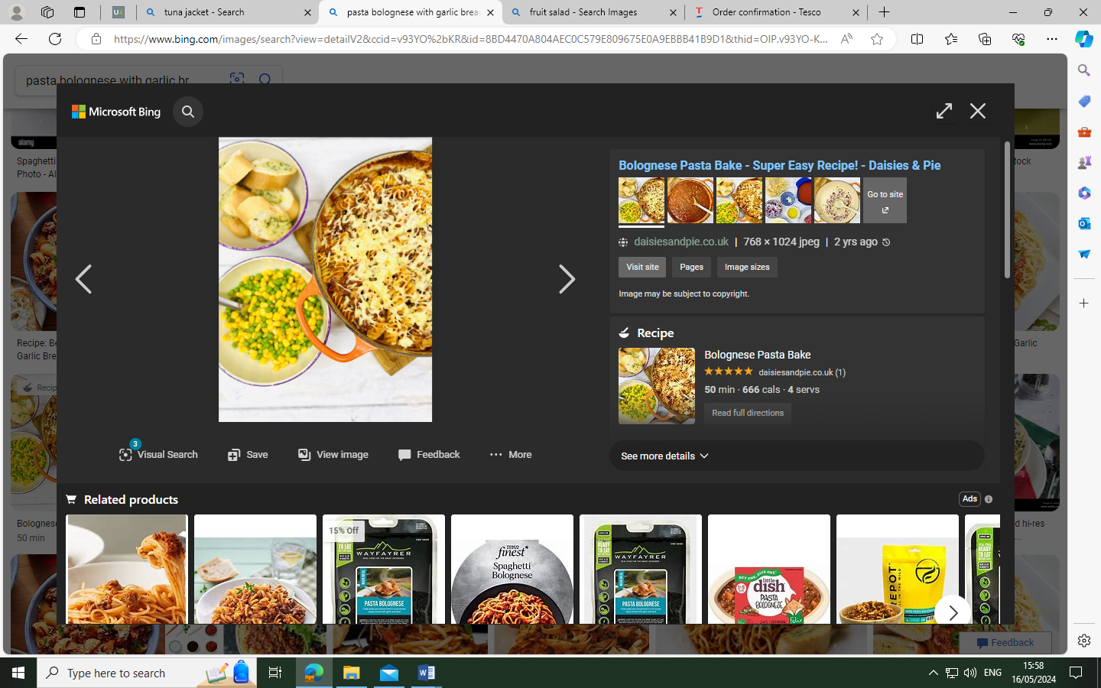 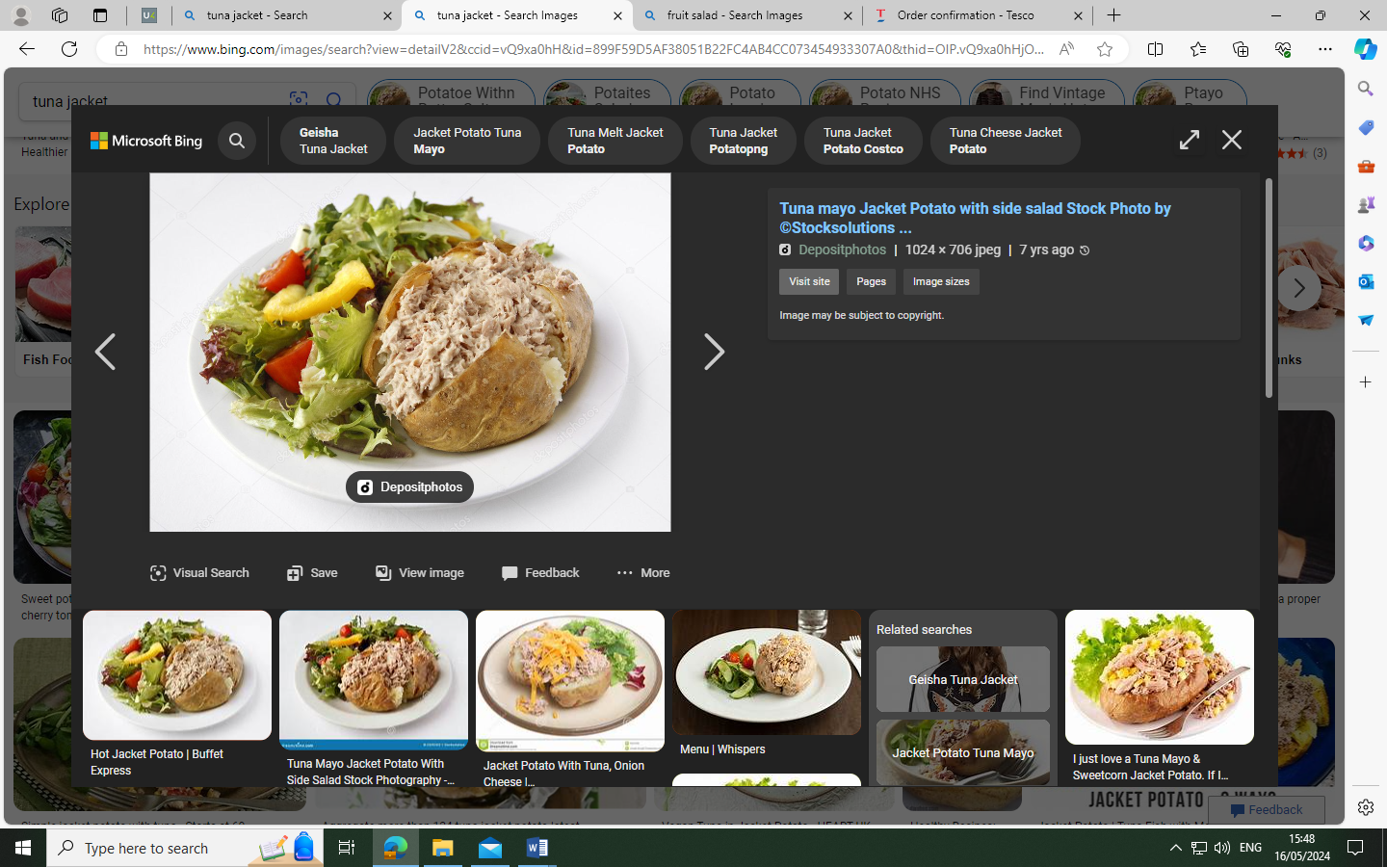 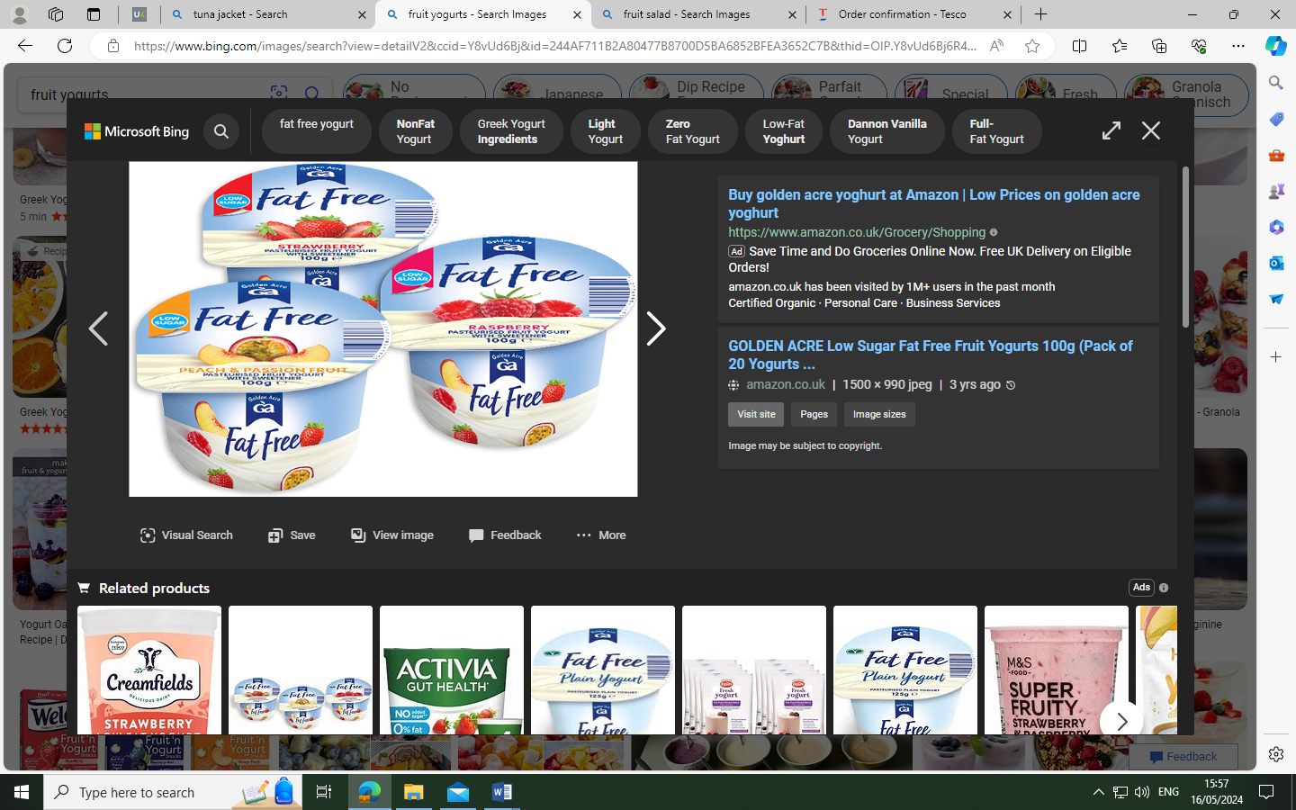
Pasta Bolognaise, Garlic Bread, Peas and Sweetcorn OR a Filled Jacket Potato
Fruit Yoghurt

Available every day, Sandwiches, Jacket Potatoes and Salad Bar.
