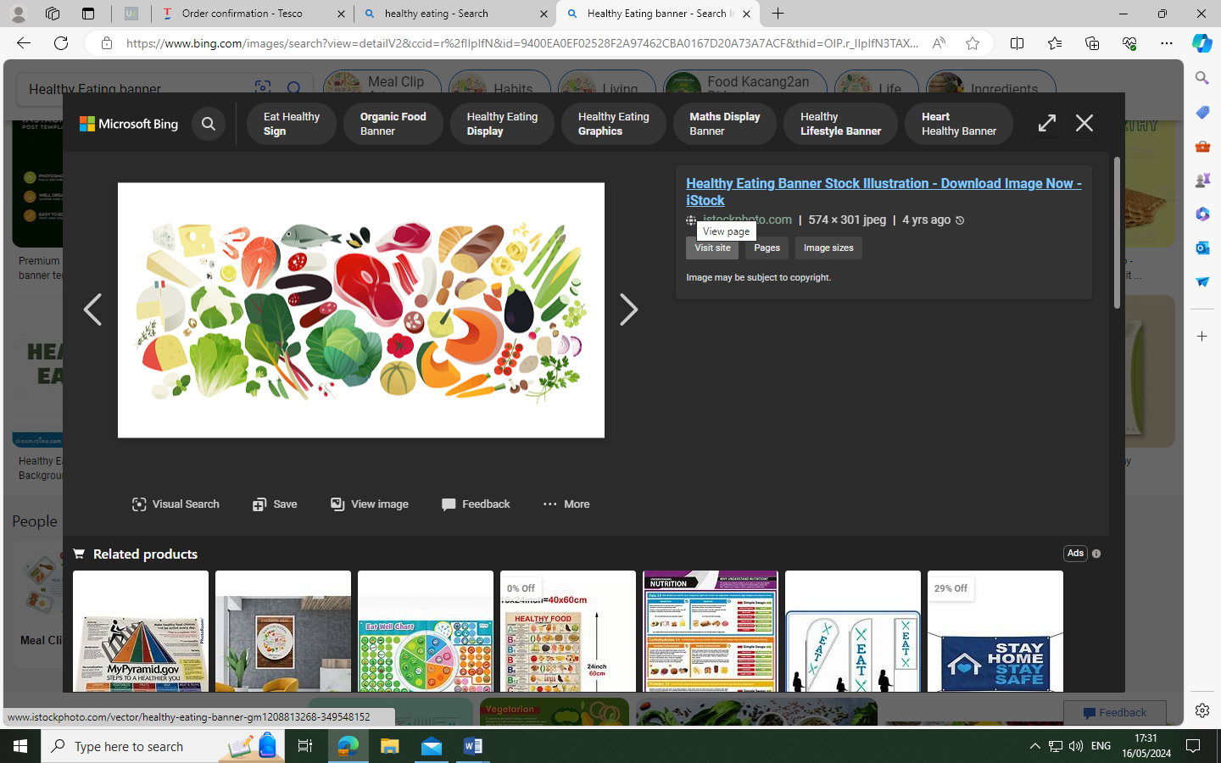
Residential Autumn Menu

Week 1. 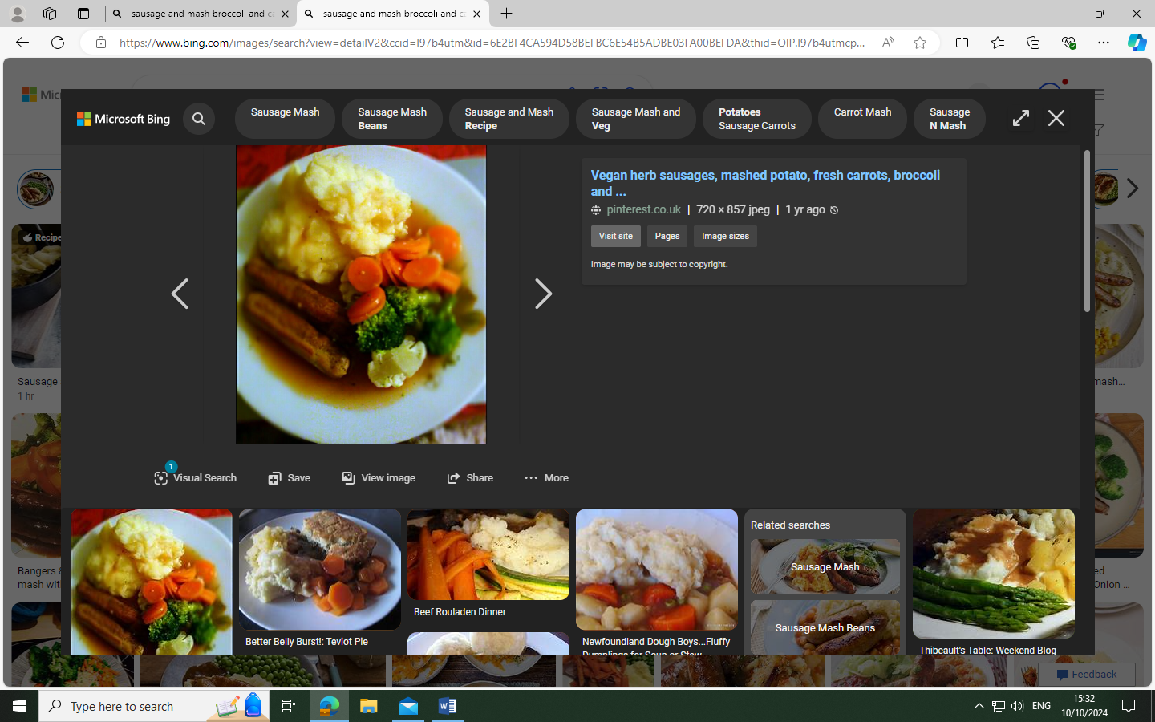 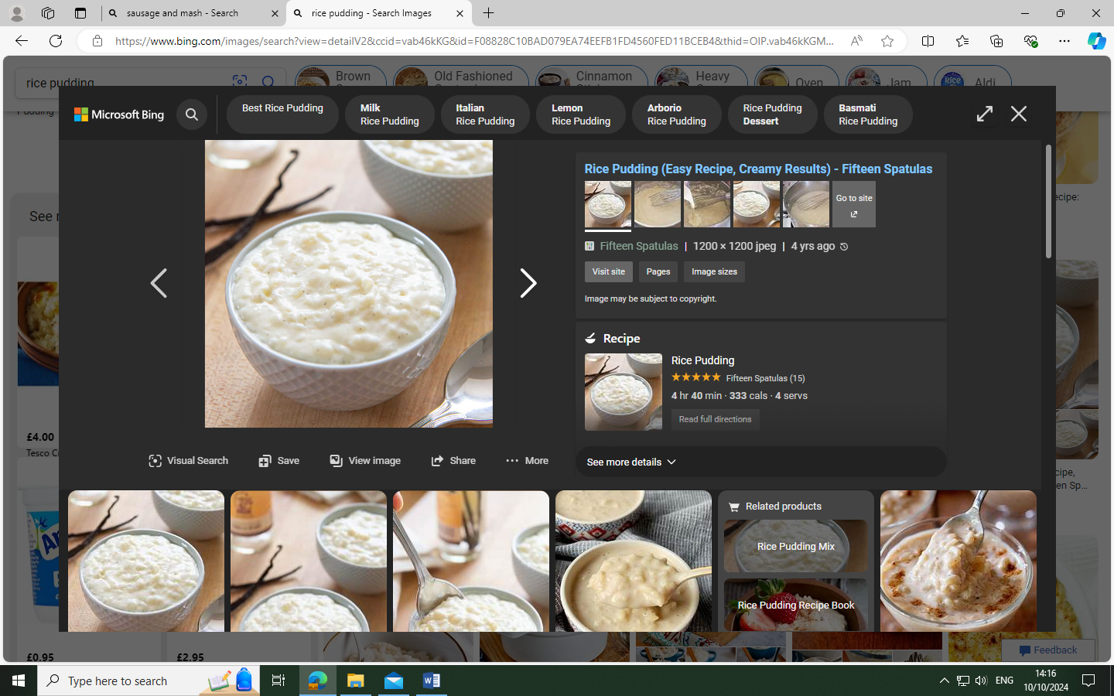 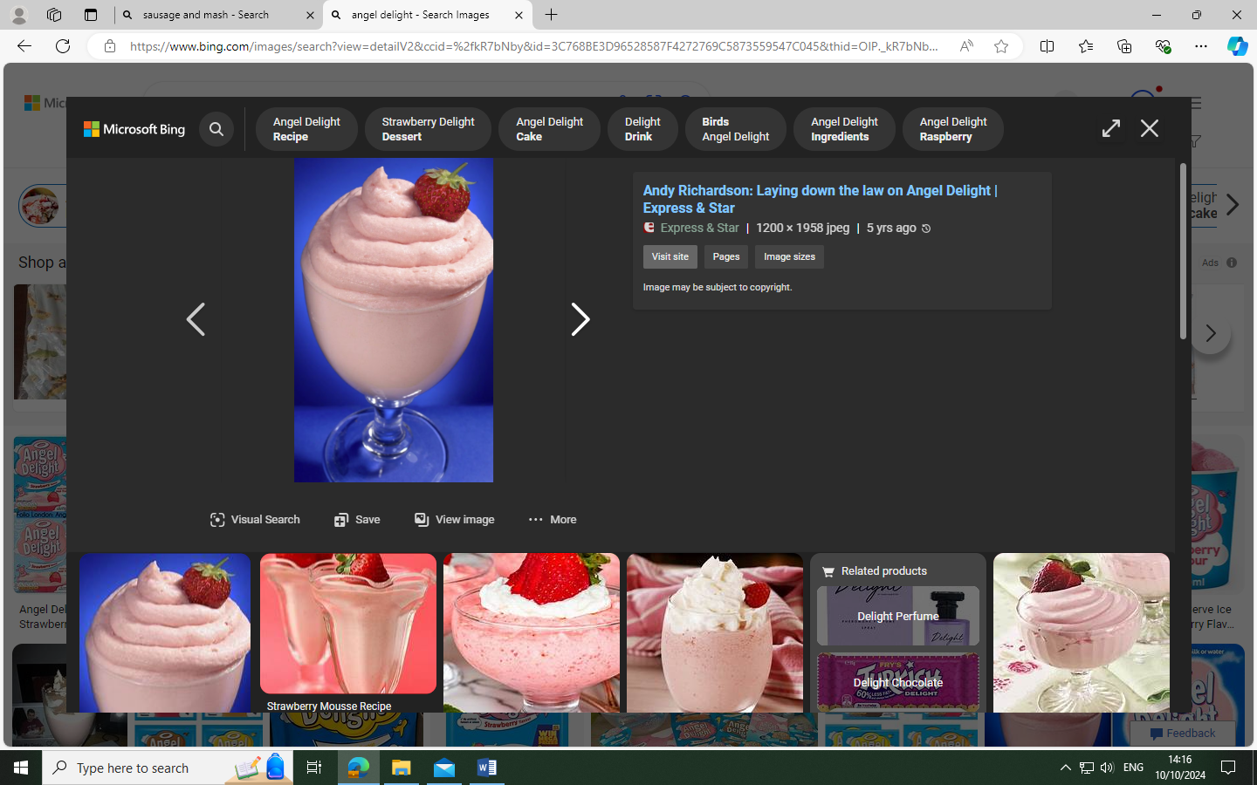
Sausage & mash, with broccoli and carrots
Rice pudding or angel delight

Week 2. 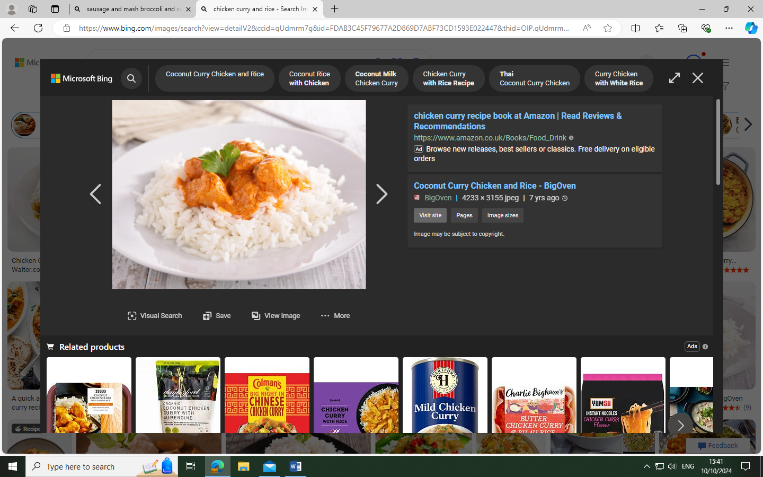 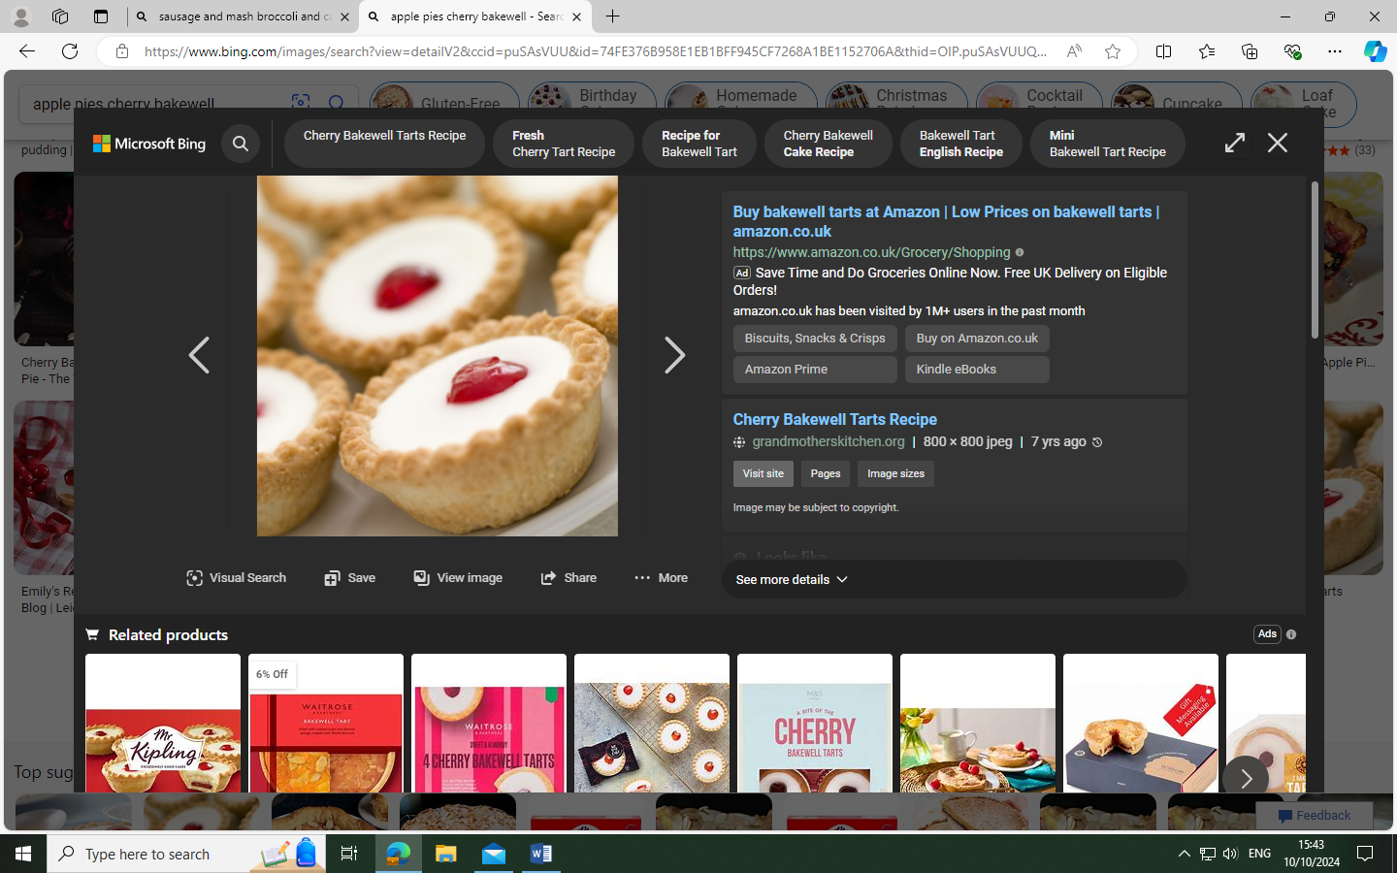
Chicken curry, with rice and peas
Fruit pies

Week 3. 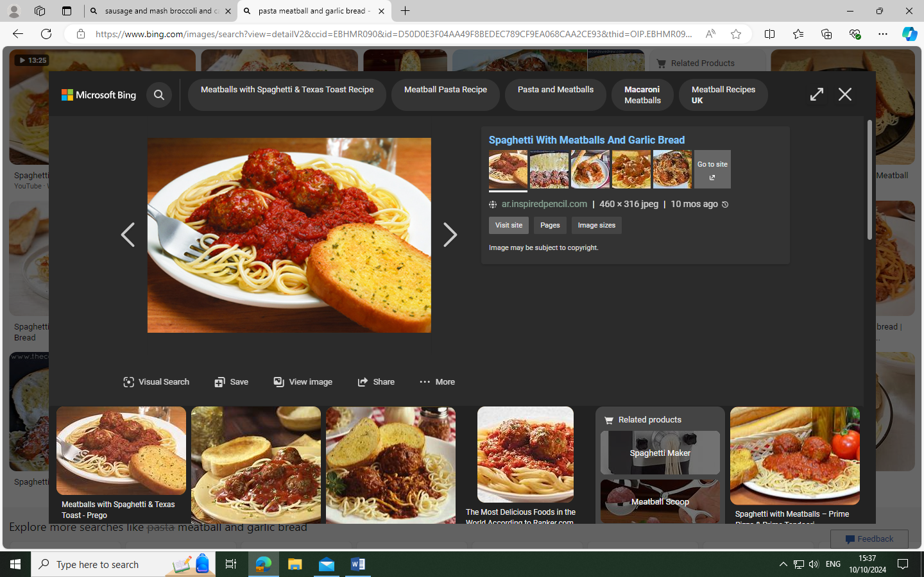 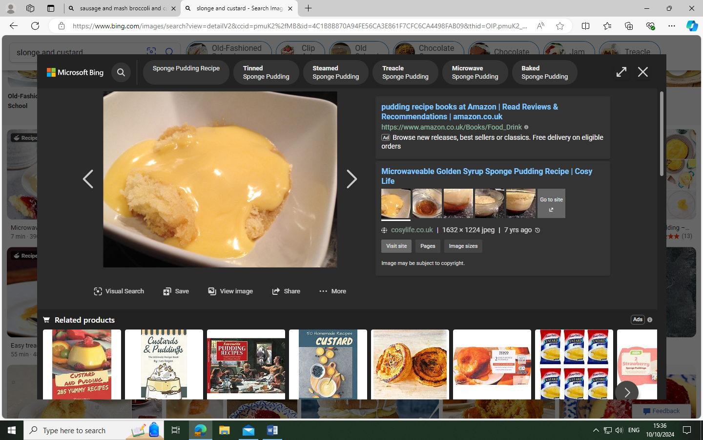
Pasta, meatballs and garlic bread with sweetcorn
Sponge and custard

Available every day, Sandwiches, Wraps, Jacket Potatoes and Salad Bar.
